**STUDIO: FEEL THE BEAT**

**Abhishek Anand**

Hip Hop| Freestyle| Animation style| Urban |Bollywood

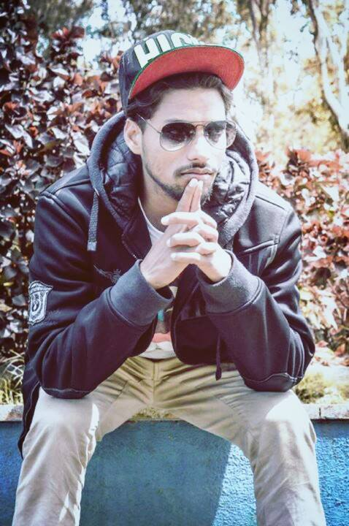

**Bio**

**Over 8 years of dance experience**

**Currently Freelancing .**

**Undergone training in broadway dance centre, workshop certification.**

**Choreographed and trained for corporates, schools over these years.**

**Attended and assisted dance and fitness workshops a various events.**

**Achievements-:**

* **Winner at Ashwamedha fest 2013.**
* **Winner at National Fest in suratkal 2013.**
* **Winner at Bounce5, Bounce 6 Open competition in Bangalore 2015, 2016.**
* **I was one of the Top 5 dancers from Karnataka get selected for ABCD2 movie promotion ,Judged by Prabhu deva,varun dhawan and shradha kapoor.**
* **Got selected for all India dance championship from Bangalore.**
* **Top 8 contestant of D3 D4DANCE Reality show .**
* **In 2017 I represented india in TEDx "ART OF ANIMATION"**

**Workshops**

* **Conducted workshop in Bhutan for Hiphop and animation style**
* **Conducted workshop in Bangalore for Popping & animation style**
* **Previously judged for summer strength competition in Kolkata.**
* **Judged for VIBGYOR**

**Choreography Work**

1. Company Choreography for corporate team from last 2 consecutive year. Successfully executed the work and aslo got lots of appreciation from company
2. College choreography -> SIT, SSIT, AMC etc.

**Contact**

Facebook: https://www.facebook.com/abhishekanand24

YouTube: https://www.youtube.com/user/abhishekanand24/videos

Email: [itsme.abhishekanand24@gmail.com](mailto:itsme.abhishekanand24@gmail.com)

Call: 8050281791